**FRONTEND WIREFRAME DOCUMENT**

**Hubba - LOGIN**

Version 1.0

Prepared By: Development Hell

Class: CECS 491-04

Date: February 19, 2023

Github Repository**:**

[**https://github.com/DevelopmentHellaHell/SeniorProject**](https://github.com/DevelopmentHellaHell/SeniorProject)

**Team Leader**

Kevin Dinh

**Members**

Garrett Tsumaki

Bryan Tran

Jett Sonoda

Tien Nguyen

Darius Koroni

# Table of Contents

Table of Contents 2

Login – Success Case 3

Login – Failure Case: 10

Wrong credentials 10

Too many attempts 11

Wrong OTP 12

OTP expired 13

References 14

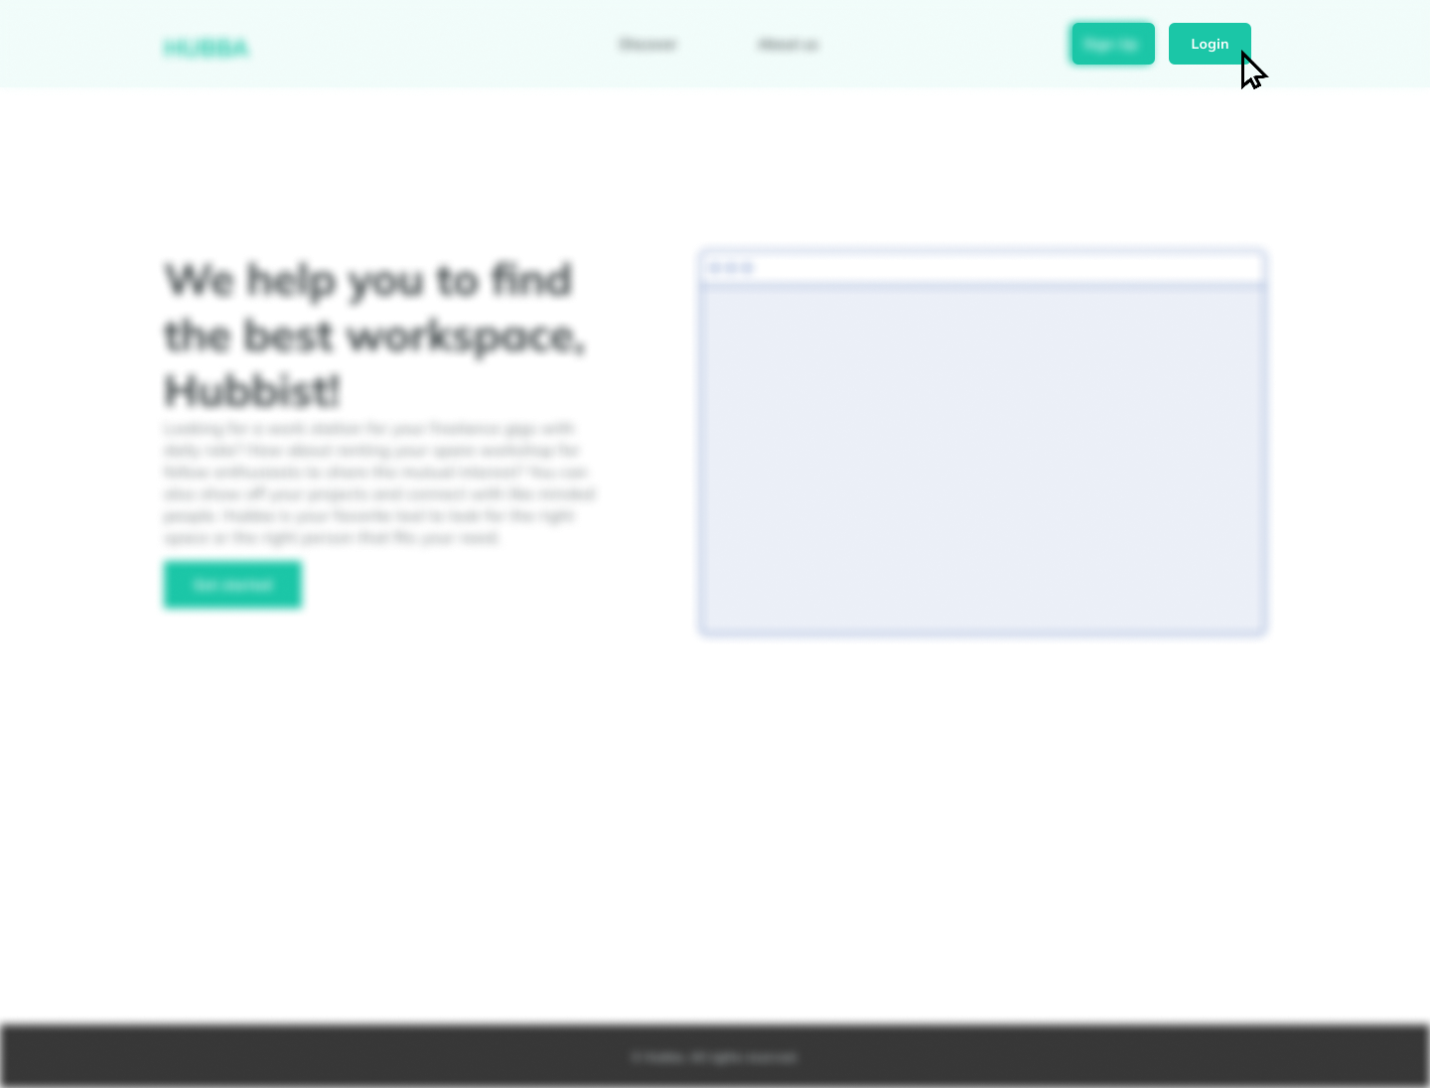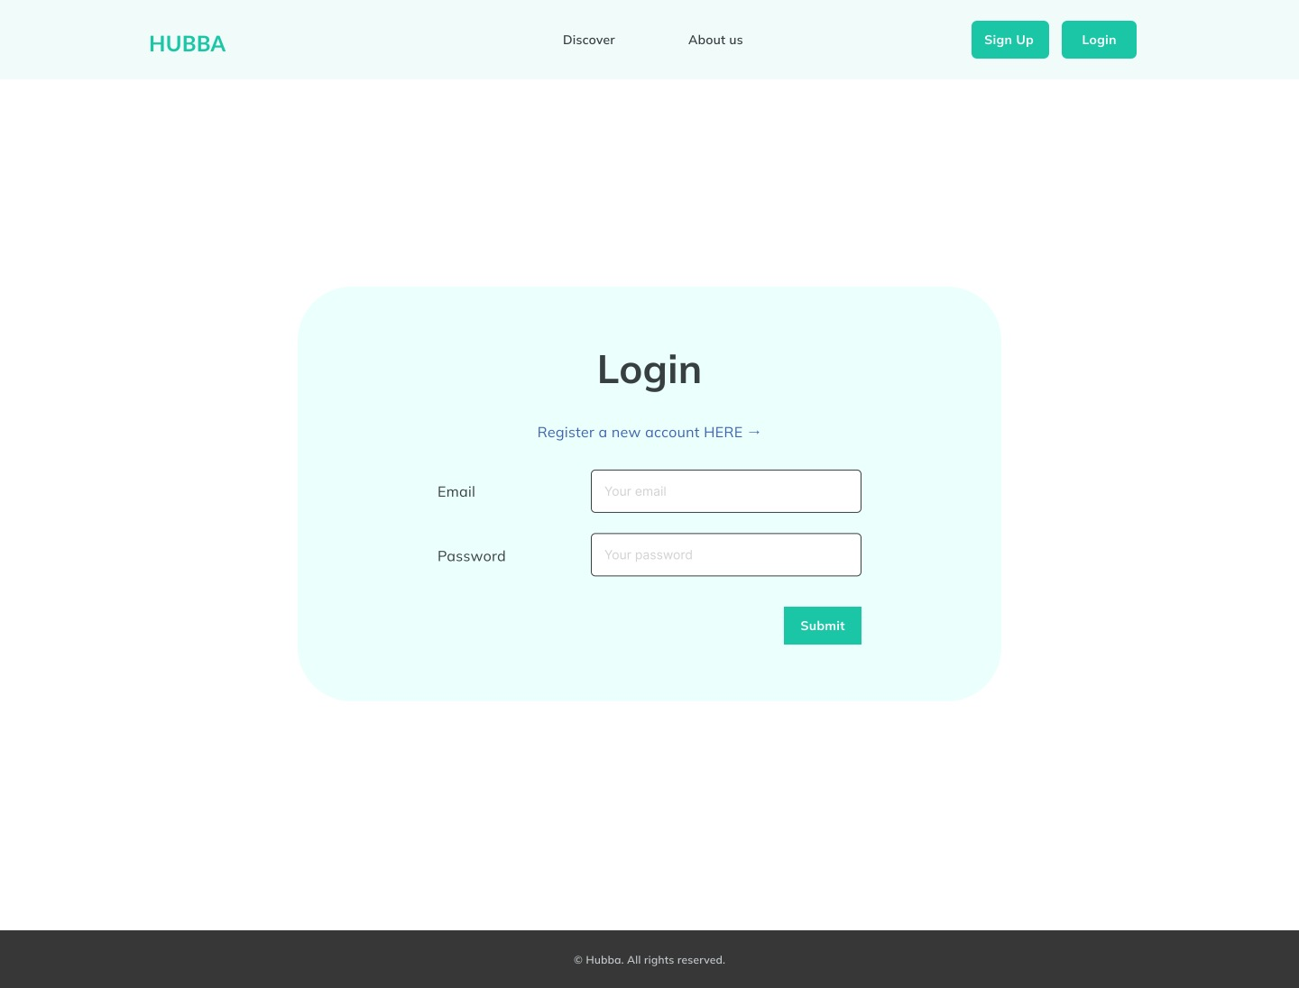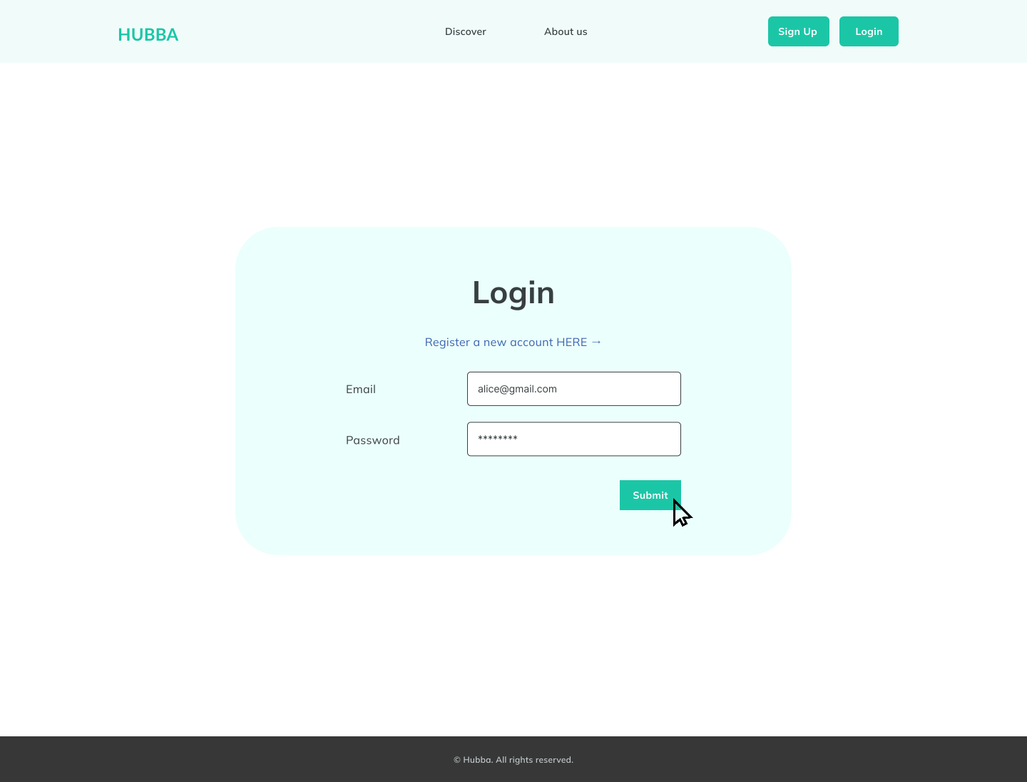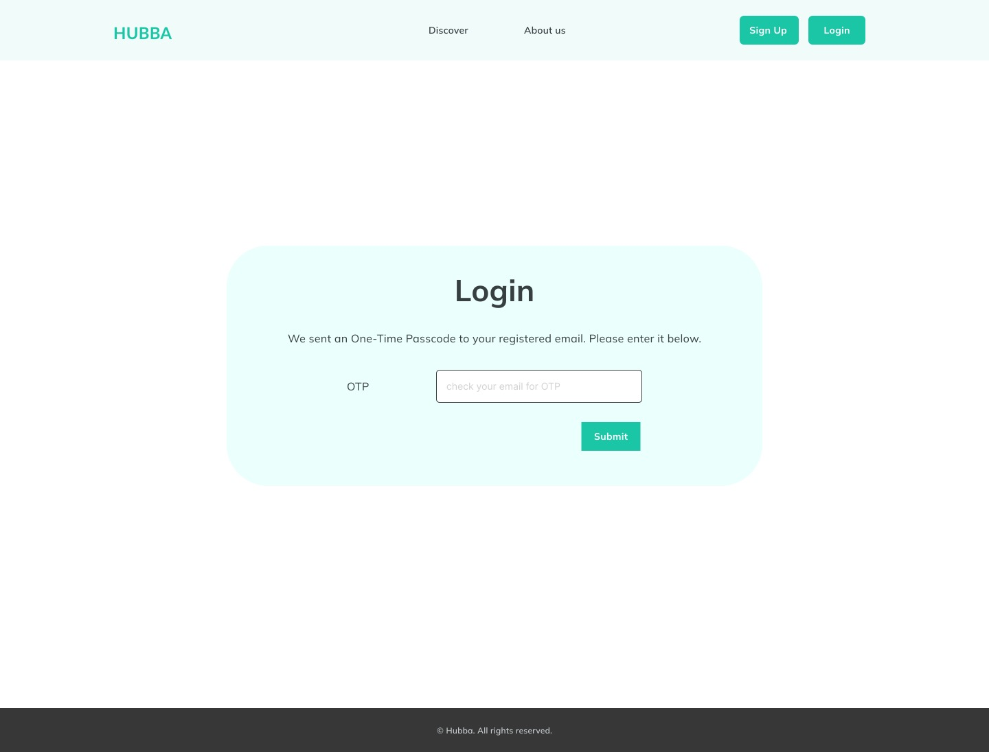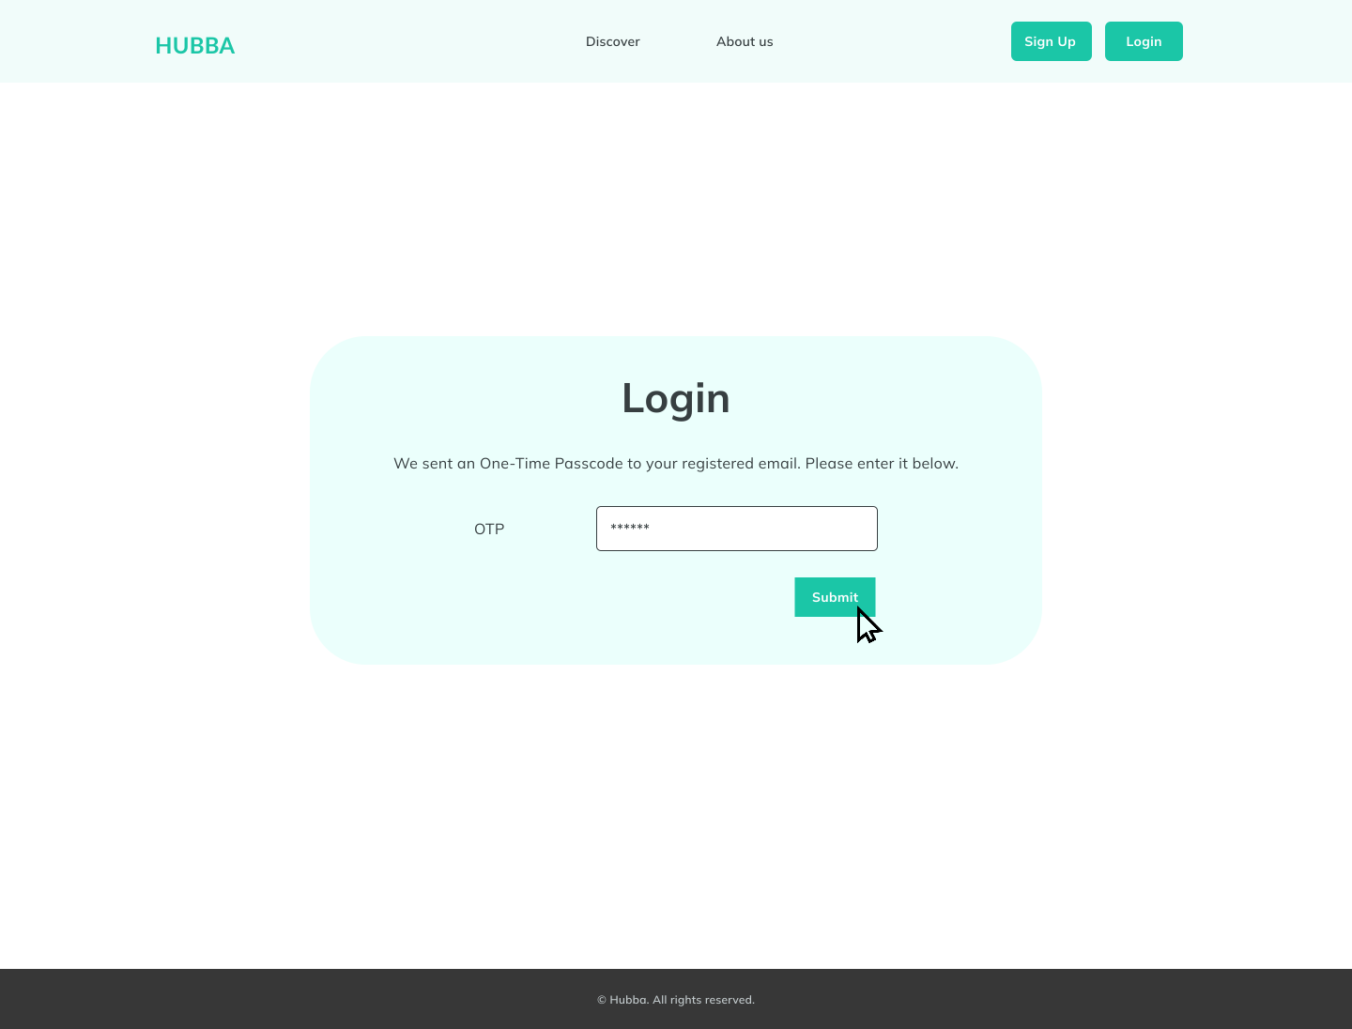

# Login – Success Case

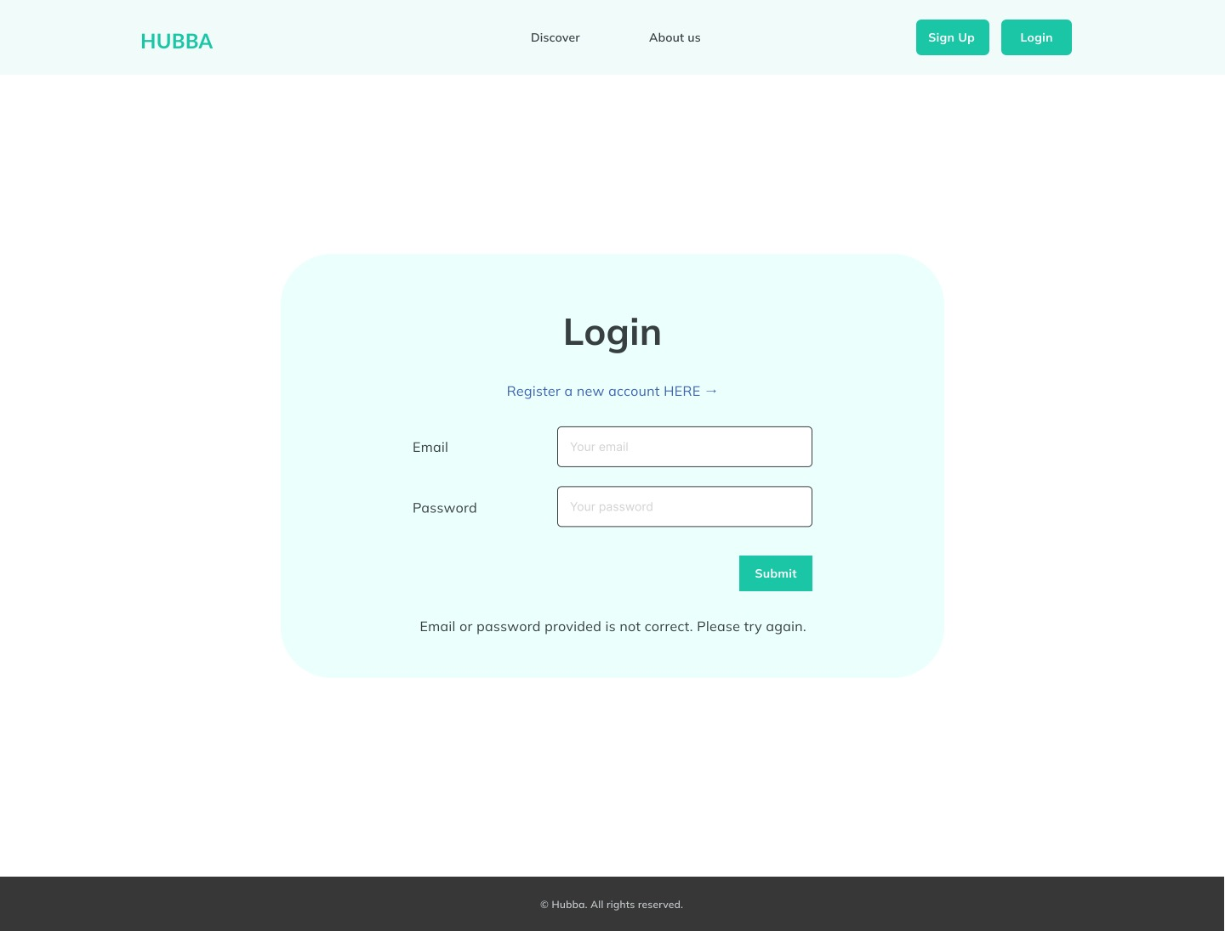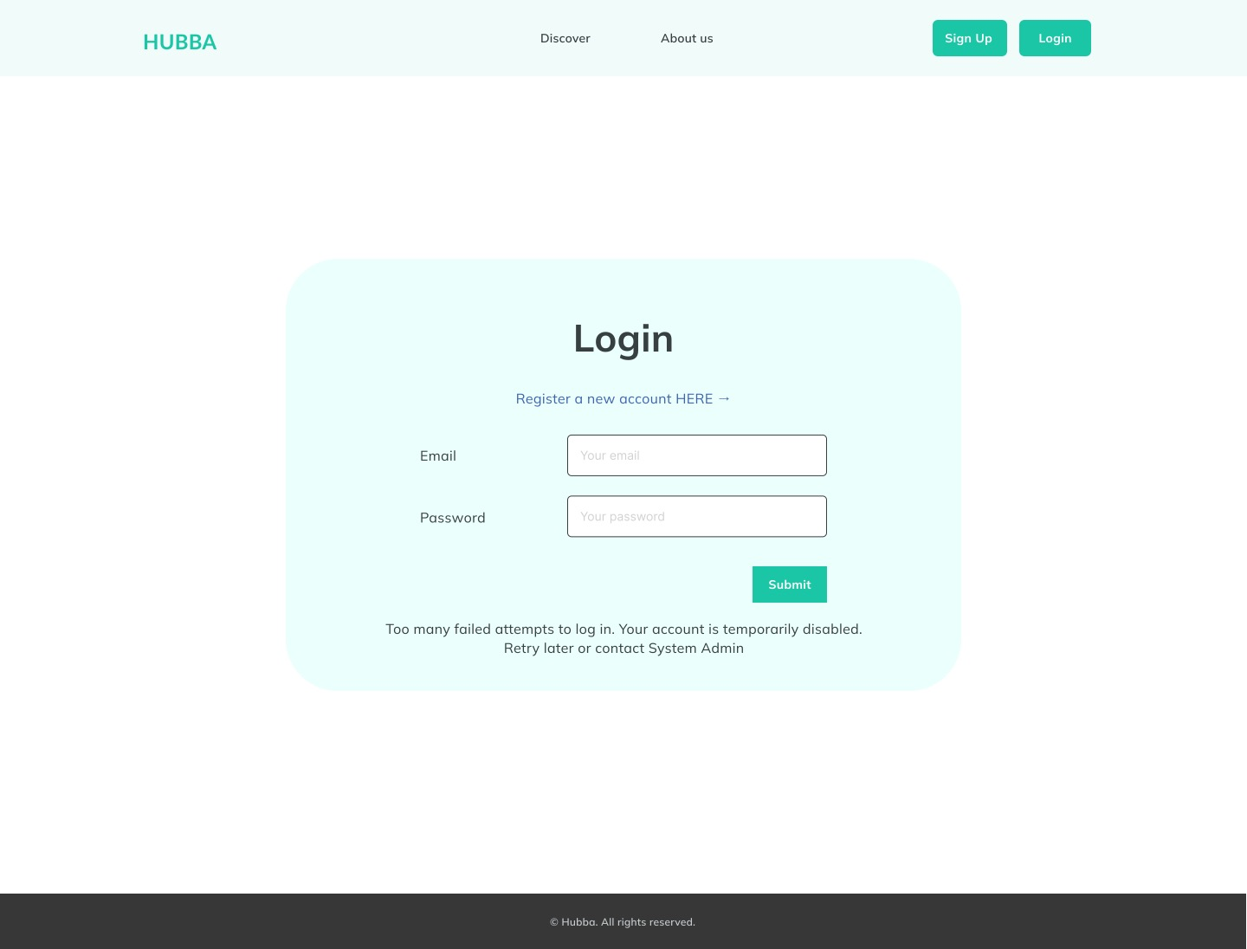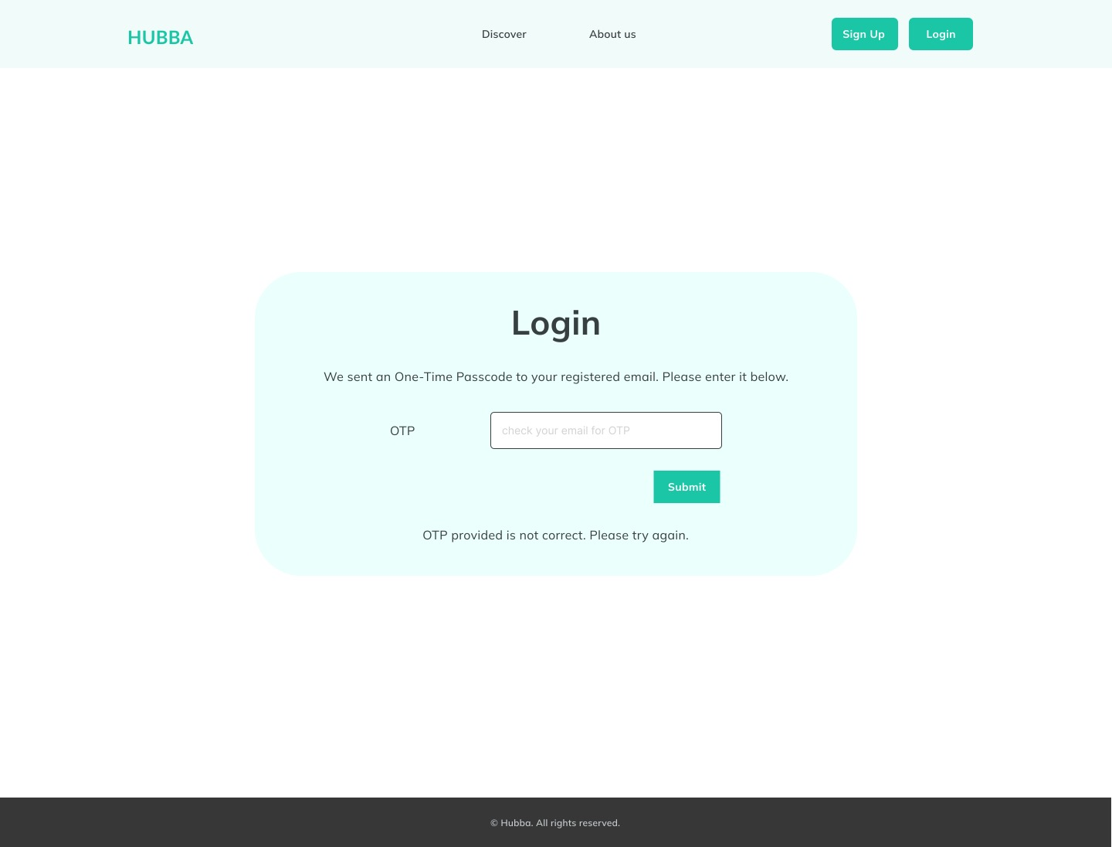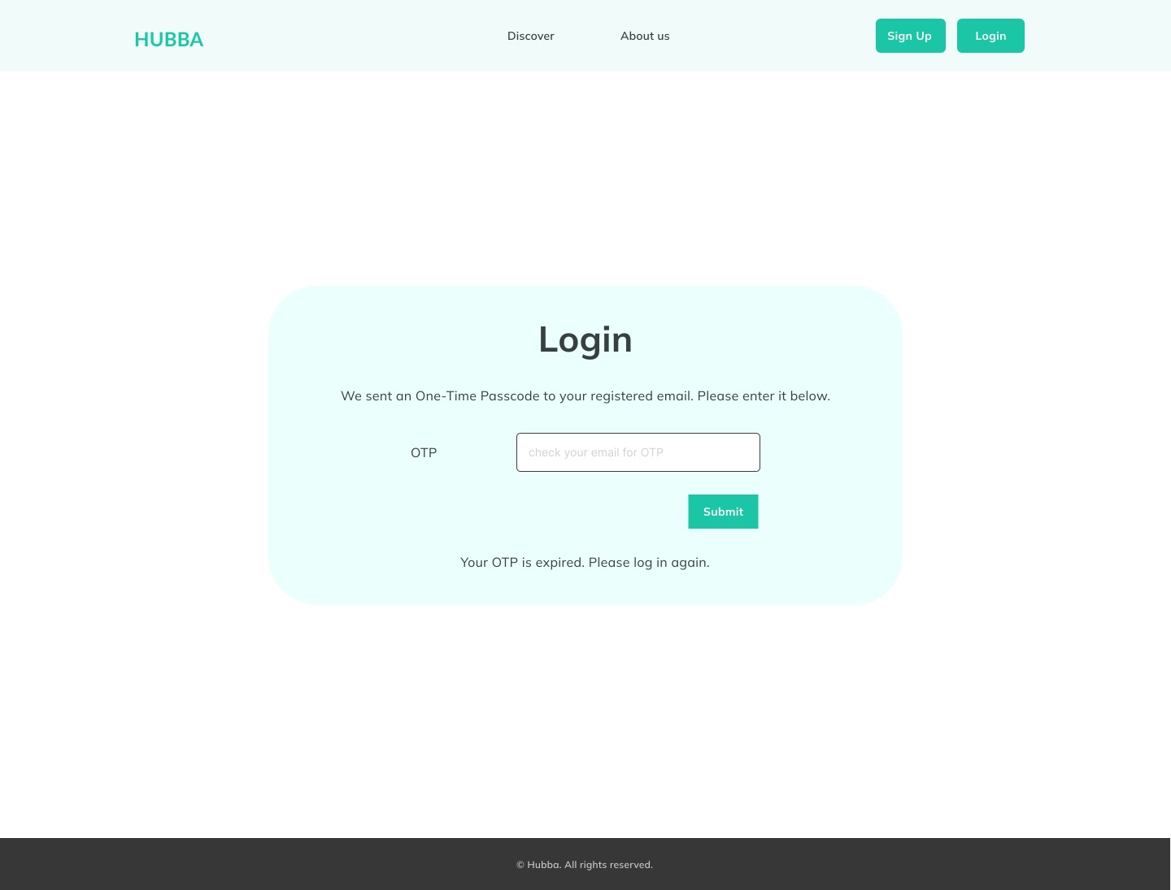

# Login – Failure Case:

## Wrong credentials

## Too many attempts

## Wrong OTP

## OTP expired

# References

The frontend wireframe is designed based on the Authentication Low-Level Design Document[1].

The wireframes included in this document utilized Figma[2].

1. Low-Level Design Document, URL: https://github.com/DevelopmentHellaHell/SeniorProject/blob/main/docs/LL%20Design/Common%20Components/Authentication/Authentication_LLDesign_v1.1.pdf
2. www.figma.com